Protocol for the Examination of Specimens from Patients with Carcinoma of the Intrahepatic Bile Ducts
Protocol applies to carcinomas of the intrahepatic bile ducts and mixed hepatocellular-cholangiocarcinoma. Hepatocellular carcinoma, hepatoblastoma, and carcinomas of the perihilar bile ducts are not included.

Based on AJCC/UICC TNM, 7th edition
Protocol web posting date: ____________
Protocol effective date: ____________

Procedure
• Hepatic resection, Partial or Complete

Authors
Kay Washington, MD, PhD, FCAP*
Department of Pathology, Vanderbilt University Medical Center, Nashville, TN
Jordan Berlin, MD
Department of Medicine, Vanderbilt University Medical Center, Nashville, TN
Philip Branton, MD, FCAP
Department of Pathology, Inova Fairfax Hospital, Falls Church, VA
Lawrence J. Burgart, MD, FCAP
Allina Laboratories, Abbott Northwestern Hospital, Minneapolis, MN
David K. Carter, MD, FCAP
Department of Pathology, St. Mary’s/Duluth Clinic Health System, Duluth, MN
Carolyn C. Compton, MD, PhD, FCAP
Office of Biorepositories and Biospecimen Research, National Cancer Institute, Bethesda, MD
Wendy L. Frankel, MD, FCAP
Department of Pathology, Ohio State University Medical Center, Columbus, OH
John Jessup, MD
Division of Cancer Treatment and Diagnosis, National Cancer Institute, Bethesda, MD
Sanjay Kakar, MD, FCAP
Department of Pathology, University of California San Francisco and the Veterans Affairs Medical Center, San Francisco, CA
Bruce Minsky, MD
Department of Radiation Oncology, University of Chicago, Chicago, IL
Raouf Nakhleh, MD, FCAP
Department of Pathology, Mayo Clinic, Jacksonville, FL
Jean-Nicolas Vauthey, MD†
Department of Surgical Oncology, University of Texas MD Anderson Cancer Center, Houston, TX
*denotes the primary author. † denotes the senior author. All other contributing authors are listed alphabetically.

For the Members of the Cancer Committee, College of American Pathologists

Previous contributors: John R. Craig, MD; Alberto Marchevsky, MD; Stephen G. Ruby, MD; Gregorio Chejfec, MD; John A. Payne, MD; Jerome B. Taxy, MD; Christopher Willett, MD; James Williams, MD

Surgical Pathology Cancer Case Summary (Checklist)

Protocol web posting date: ____________
Protocol effective date: ____________

Intrahepatic Bile Ducts: Resection (Note A)

Select a single response unless otherwise indicated.

Specimen (select all that apply)
___Liver
___Gallbladder
___Other (specify): _____________________________
___ Not specified

Procedure (select all that apply)
___ Wedge resection
___ Partial hepatecomy
*___ Major hepatectomy (3 segments or more)
*___ Minor hepatectomy (less than 3 segments)
___ Total hepatectomy
___ Other (specify): ____________________________
___ Not specified

Tumor Size
Greatest dimension: ___ cm
*Additional dimensions: ___ x ___ cm
___ Cannot be determined (see Comment)

Tumor Focality (Note B)
___ Solitary (specify location): ____________________________
___ Multiple (specify locations): ____________________________

Histologic Type (Note C)
___ Cholangiocarcinoma
___ Combined hepatocellular and cholangiocarcinoma
___ Bile duct cystadenocarcinoma
___ Other (specify): ___________________________

Histologic Grade (Note D)
___ Not applicable
___ GX: Cannot be assessed
___ GI: Well differentiated
___ GII: Moderately differentiated
___ GIII: Poorly differentiated
___ GIV: Undifferentiated
___ Other (specify): ____________________________

Tumor Growth Pattern (Note E)
___ Mass-forming
___ Periductal infiltrating
___ Mixed mass-forming and periductal infiltrating
___ Cannot be determined

Microscopic Tumor Extension (select all that apply)
___ Cannot be assessed
___ No evidence of primary tumor
___ Tumor confined to the intrahepatic bile ducts histologically (carcinoma in situ)
___ Tumor confined to hepatic parenchyma
___ Tumor involves visceral peritoneal surface
___ Tumor directly invades gallbladder
___ Tumor directly invades adjacent organs other than the gallbladder (specify):____________________

Margins (select all that apply) (Note F)

Hepatic Parenchymal Margin
___ Cannot be assessed
___ Uninvolved by invasive carcinoma
Distance of invasive carcinoma from closest margin: ___ mm
Specify margin: ____________________________
___ Involved by invasive carcinoma

Bile Duct Margin
___ Cannot be assessed
___ Uninvolved by invasive carcinoma
*___ Dysplasia/Carcinoma in situ not identified
*___ Dysplasia/Carcinoma in situ present
___ Involved by invasive carcinoma

Other Margin
Specify margin: ____________________________
___ Cannot be assessed
___ Uninvolved by invasive carcinoma
___ Involved by invasive carcinoma

Lymph-Vascular Invasion

Venous (Major Vessel) Invasion (V) (invasion of right or left portal vein, one or more hepatic veins)

___ Not identified
___ Present
___ Indeterminate

Small Vessel Invasion (L)
___ Not identified
___ Present
___ Indeterminate

*Perineural Invasion
*___ Not identified
*___ Present
*___ Indeterminate

Pathologic Staging (pTNM) (Note F)

TNM Descriptors (Required only if applicable) (Select all that apply)
___ m (multiple primary tumors)
___ r (recurrent)
___ y (post-treatment)

Primary Tumor (pT)
___ pTX: Cannot be assessed
___ pT0: No evidence of primary tumor
___pTis: Carcinoma in situ (intraductal tumor)
___pT1: Solitary tumor without vascular invasion
___pT2a: Solitary tumor with vascular invasion
___pT2b: Multiple tumors, with or without vascular invasion
___pT3: Tumor perforates the visceral peritoneum or involves local extra- hepatic structures by direct invasion
___pT4: Tumor with periductal invasion

Regional Lymph Nodes (pN) (Note G)
___ pNX: Cannot be assessed
___ pN0: No regional lymph node metastasis
___ pN1: Regional lymph node metastasis
Specify: Number examined: ___
Number involved: ___

Distant Metastasis (pM)
___ Not applicable
___ pM1: Distant metastasis
*Specify site(s), if known: ____________________________

*Additional Pathologic Findings (select all that apply) (Note H)
*___ Cirrhosis/severe fibrosis (Ishak fibrosis score 5-6)
*___ Primary sclerosing cholangitis
*___ Biliary stones
*___ Chronic Hepatitis (specify type): ____________________________
*___ Other (specify): ____________________________
*___ None identified

*Ancillary Studies (Note G)
*Specify: ___________________________________

*Clinical History (select all that apply)
*____ Cirrhosis
*____ Primary sclerosing cholangitis
*____ Inflammatory bowel disease
*____ Hepatitis C infection
*____ Other (specify): ______________________________
*____ Not known

*Comment(s)

Explanatory Notes

A. Application
This protocol applies only to hepatic resection specimens containing carcinomas arising in the intrahepatic bile ducts. Hepatocellular carcinomas and carcinomas arising in the perihilar bile ducts are staged using separate TNM systems¹. A separate staging system for intrahepatic cholangiocarcinoma is warranted on the basis of biological differences in tumor behavior and prognostic factors, such as lack of prognostic impact of tumor size for cholangiocarcinoma compared to hepatocellular carcinoma¹.

Anatomically the intrahepatic bile ducts extend from the periphery of the liver to the second order bile duct ducts (Figure 1). The perihilar bile ducts extend from the hepatic duct bifurcation to include the extrahepatic biliary tree proximal to the origin of the cystic duct. The distal extrahepatic bile duct extends the junction of the cystic duct-bile duct to the Ampulla of Vater¹.

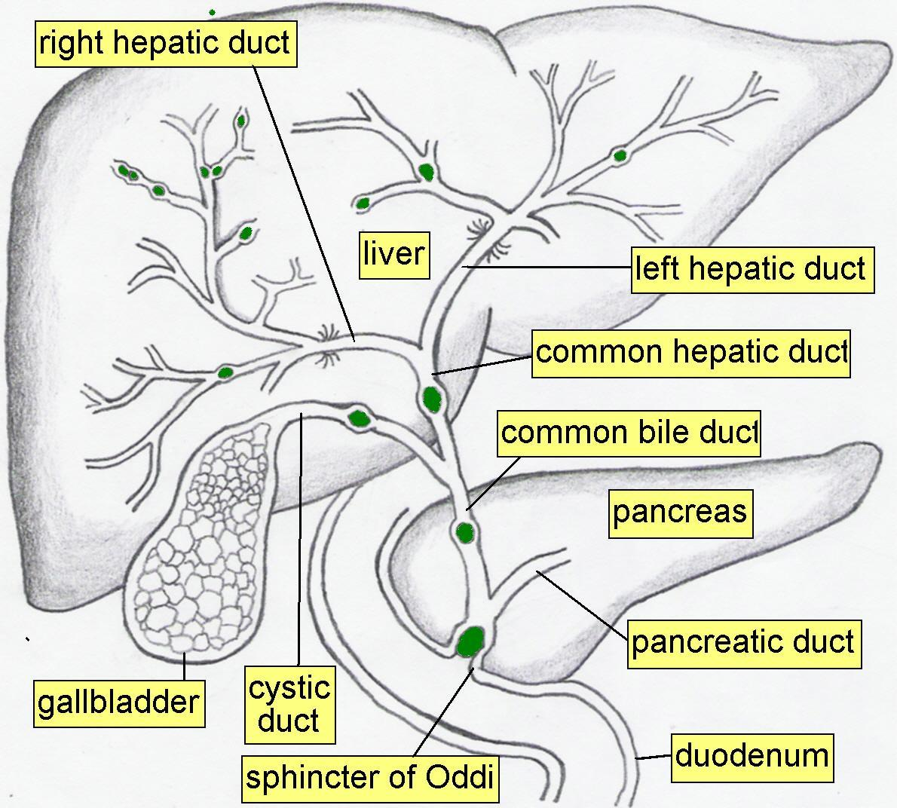

Figure 1. Anatomy of the intra-and extrahepatic biliary system.

B. Tumor Focality
Sections should be prepared from each major tumor nodule with representative sampling of smaller nodules, if macroscopically different in appearance. For purposes of staging, satellite nodules, multifocal primary cholangiocarcinomas, and intrahepatic metastases are not distinguished and are considered multiple tumors¹. In intrahepatic cholangiocarcinoma, multiple tumor deposits have been associated with poorer survival^{2, 3}.

C. Histologic Type
The protocol recommends the following modified classification of the World Health Organization (WHO)⁴. In the United States, roughly 30% of the primary malignant tumors of the liver are biliary carcinomas⁴.

WHO Classification of Carcinomas of the Intrahepatic Bile Ducts (Modified)
Cholangiocarcinoma
Combined hepatocellular and cholangiocarcinoma
Bile duct cystadenocarcinoma

Combined hepatocellular/cholangiocarcinoma accounts for less than 5% of primary liver carcinomas⁵ and should show histologic evidence of both hepatocellular differentiation and bile duct differentiation, such as production of mucin. These tumors generally have a poor prognosis and often arise in the setting of cirrhosis^{5, 6}. Recent studies have found genetic changes similar to those seen in cholangiocarcinoma⁷.

D. Histologic Grade

For cholangiocarcinomas, definitive criteria for histologic grading have not been established; however the following quantitative grading system based on the proportion of gland formation within the tumor is suggested.

Grade X Grade cannot be assessed
Grade 1 Well differentiated (more than 95% of tumor composed of glands)
Grade 2 Moderately differentiated (50% to 95% of tumor composed of glands)
Grade 3 Poorly differentiated (5% to 49% of tumor composed of glands)
Grade 4 Undifferentiated (less than 5% of tumor composed of glands)

E. Tumor Growth Pattern

Three tumor growth patterns of intrahepatic cholangiocarcinoma are described: the mass forming type, the periductal infiltrating type, and mixed mass-forming periductal infiltrating type. Mass forming intrahepatic cholangiocarcinoma (60% of cases) forms a well demarcated nodule growing in a radial pattern and invading the adjacent liver parenchyma (Figure 2). In contrast, the periductal infiltrating type of cholangiocarcinoma (20% of cases) spreads in a diffuse longitudinal growth pattern along the bile duct. The remaining 20% of cases of intrahepatic cholangiocarcinoma grow in a mixed mass-forming/periductal infiltrating pattern. Limited analyses suggest that the diffuse periductal infiltrating type is associated with a poor prognosis^{2, 8}.

Figure 2. Tumor growth pattern in intrahepatic cholangiocarcinoma.

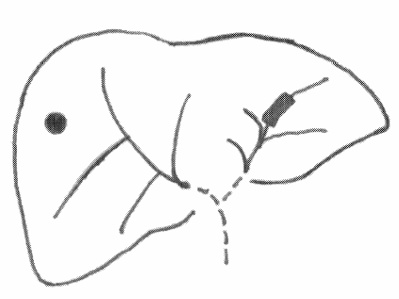

E. Margins
The evaluation of margins for total or partial hepatectomy specimens depends on the method and extent of resection. It is recommended that the surgeon be consulted to determine the critical foci within the margins that require microscopic evaluation. The transection margin of a partial hepatectomy may be large, rendering it impractical for complete examination. In this setting, grossly positive margins should be microscopically confirmed and documented. If the margins are grossly free of tumor, judicious sampling of the cut surface in the region closest to the nearest identified tumor nodule is indicated. In selected cases, adequate random sampling of the cut surface may be sufficient. The histologic examination of the bile ducts at the cut margin is recommended to evaluate the lining epithelium for in situ carcinoma or dysplasia. If the neoplasm is found near the surgical margin, the distance from the margin should be reported. For multiple tumors, the distance from the nearest tumor should be reported.

F. TNM and Anatomic Stage/Prognostic Groupings
The TNM staging system of the American Joint Committee on Cancer (AJCC) and the International Union Against Cancer (UICC)¹ applies to all primary carcinomas of the intrahepatic bile ducts and mixed hepatocellular/cholangiocarcinomas. It does not apply to hepatic sarcomas or to metastatic tumors of the liver.
By AJCC/UICC convention, the designation “T” refers to a primary tumor that has not been previously treated. The symbol “p” refers to the pathologic classification of the TNM, as opposed to the clinical classification, and is based on gross and microscopic examination. pT entails a resection of the primary tumor or biopsy adequate to evaluate the highest pT category, pN entails removal of nodes adequate to validate lymph node metastasis, and pM implies microscopic examination of distant lesions. Clinical classification (cTNM) is usually carried out by the referring physician before treatment during initial evaluation of the patient or when pathologic classification is not possible.

Pathologic staging is usually performed after surgical resection of the primary tumor. Pathologic staging depends on pathologic documentation of the anatomic extent of disease, whether or not the primary tumor has been completely removed. If a biopsied tumor is not resected for any reason (eg, when technically unfeasible) and if the highest T and N categories or the M1 category of the tumor can be confirmed microscopically, the criteria for pathologic classification and staging have been satisfied without total removal of the primary cancer.

TNM Descriptors
For identification of special cases of TNM or pTNM classifications, the “m” suffix and “y,” “r,” and “a” prefixes are used. Although they do not affect the stage grouping, they indicate cases needing separate analysis.

The “m” suffix indicates the presence of multiple primary tumors in a single site and is recorded in parentheses: pT(m)NM.

The “y” prefix indicates those cases in which classification is performed during or following initial multimodality therapy (ie, neoadjuvant chemotherapy, radiation therapy, or both chemotherapy and radiation therapy). The cTNM or pTNM category is identified by a “y” prefix. The ycTNM or ypTNM categorizes the extent of tumor actually present at the time of that examination. The “y” categorization is not an estimate of tumor prior to multimodality therapy (ie, before initiation of neoadjuvant therapy).

The “r” prefix indicates a recurrent tumor when staged after a documented disease-free interval, and is identified by the “r” prefix: rTNM.

The “a” prefix designates the stage determined at autopsy: aTNM.

T Category Considerations
Intraductal papillary bile duct tumors may be identified in some patients with biliary obstruction and are classified as in situ tumors (Tis).

The T classification depends on the number of tumor nodules and the presence or absence of blood vessel invasion.

The TNM classification does not discriminate between multiple independent primary tumors, tumor satellite nodules, or intra-hepatic metastasis from a single primary carcinoma.

Vascular invasion includes either the gross involvement of large vessels or the microscopic involvement of small vessels identified on histologic examination. Major vascular invasion is defined as invasion of the branches of the main portal vein (right or left portal vein) or as invasion of one or more of the three hepatic veins (right, middle or left).

Direct invasion of adjacent organs, including colon, duodenum, stomach, common bile duct, portal lymph nodes, abdominal wall, and diaphragm is considered T3 disease, not as metastases.
Tumors with periductal growth pattern (diffuse longitudinal growth pattern along the intrahepatic bile ducts on both gross and microscopic examination) or mixed mass-forming and periductal infiltrating growth pattern are classified as T4.

Primary Tumor (T)
TX Primary tumor cannot be assessed
T0 No evidence of primary tumor
Tis Carcinoma in situ (intraductal tumor)
T1 Solitary tumor without vascular invasion
T2a Solitary tumor with vascular invasion
T2b Multiple tumors, with or without vascular invasion
T3 Tumor perforates the visceral peritoneum or involves local extra- hepatic structures by direct invasion
T4 tumor with periductal invasion

Regional Lymph Nodes (N)
NX Regional lymph nodes cannot be assessed
N0 No regional lymph node metastasis
N1 Regional lymph node metastasis

Distant Metastasis (M)
MX Distant metastasis cannot be assessed
M0 No distant metastasis
M1 Distant metastasis

Stage Groupings
Stage I T1 N0 M0
Stage II T2 N0 M0
Stage III T3 N0 M0
Stage IVA T4 N0 M0
Any T N1 M0
Stage IVB Any T Any N M1

Additional Descriptors

Lymph-Vascular Invasion (LVI):
LVI indicates whether microscopic lymph-vascular invasion is identified and includes lymphatic invasion, vascular invasion, or lymph-vascular invasion. By AJCC/UICC convention, LVI does not affect the T category indicating local extent of tumor unless specifically included in the definition of a T category.

G. Lymph Nodes
Lymph node metastases have consistently been identified as an important predictor of outcome for intrahepatic cholangiocarcinoma^{1, 2, 9}. Histologic examination of a regional lymphadenectomy specimen usually involves examination of 3 or more lymph nodes.

The lymph node involvement pattern for intrahepatic cholangiocarcinomas varies with location in the liver (Figure 3). For biliary carcinomas arising in the right lobe of the liver (segments 5-8), the regional lymph nodes include the hilar (common bile duct, hepatic artery, portal vein, and cystic duct), periduodenal, and peripancreatic lymph nodes. For tumors arising in the left lobe the regional lymph nodes are the hilar and gastrohepatic lymph nodes. Nodal involvement of the celiac, periaortic, or caval lymph nodes is considered to be distant metastasis (pM1)¹.

Figure 3. Segmental anatomy of the liver (14.2 from 6th edition staging atlas).

H. Additional Pathologic Findings
Cirrhosis (Ishak score 6) or severe fibrosis (Ishak score 5, marked bridging fibrosis with occasional nodules)¹⁰ should be specifically reported since it has an adverse effect on outcome. The presence of underlying disease, such as primary sclerosing cholangitis, should be included in the pathology report.

I. Clinical History
Roughly 10% of intrahepatic cholangiocarcinomas arise in the setting of chronic inflammatory conditions affecting the intrahepatic bile ducts¹¹ . The most common risk factor for intrahepatic cholangiocarcinoma in the United States is biliary cirrhosis, generally in the setting of primary sclerosing cholangitis. In Asian countries, biliary parasites and recurrent pyogenic cholangitis are also etiologic factors. Recently studies suggest that hepatitis C infection, non-alcoholic fatty liver disease, obesity, and smoking are also risk factors for the development of this tumor^{12, 13}.

References

1. Edge SE, Byrd DR, Carducci MA, Compton CA, eds. AJCC Cancer Staging Manual. 7th ed. New York, N. Y.: Springer; 2009.
2. Ohtsuka M, Ito H, Kimura F, et al. Results of surgical treatment for intrahepatic cholangiocarcinoma and clinicopathological factors influencing survival. British Journal of Surgery. Dec 2002;89(12):1525-1531.
3. Sano T, Shimada K, Sakamoto Y, Ojima H, Esaki M, Kosuge T. Prognosis of perihilar carcinoma: hilar bile duct cancer versus intrahepatic cholangiocarcinoma involving the hepatic hilus. Annals of Surgical Oncology. 2008;15(2):590-599.
4. Hamilton SR, Aaltonen LA, eds. World Health Organization Classification of Tumours. Pathology and Genetics of Tumours of the Digestive System. Lyon: IARC Press; 2000.
5. Lee W-S, Lee K-W, Heo J-S, et al. Comparison of combined hepatocellular and cholangiocarcinoma with hepatocellular carcinoma and intrahepatic cholangiocarcinoma. Surgery Today. 2006;36(10):892-897.
6. Koh KC, Lee H, Choi MS, et al. Clinicopathologic features and prognosis of combined hepatocellular cholangiocarcinoma. American Journal of Surgery. 2005;189(1):120-125.
7. Cazals-Hattem D, Rebouissou S, Bioulac-Sage P, et al. Clinical and molecular analysis of combined hepatocellular-cholangiocarcinomas. Journal of Hepatology. 2004;41(2):292-298.
8. Shimada K, Sano T, Sakamoto Y, Esaki M, Kosuge T, Ojima H. Surgical outcomes of the mass-forming plus periductal infiltrating types of intrahepatic cholangiocarcinoma: a comparative study with the typical mass-forming type of intrahepatic cholangiocarcinoma. World Journal of Surgery. 2007;31(10):2016-2022.
9. Ishak KG, Goodman ZD, Stocker JT. Tumors of the Liver and Intrahepatic Bile Ducts. Vol 3rd series, fascicle 31. Washington, DC: Armed Forces Institute of Pathology; 2001.
10. Ishak K, Baptista A, Bianchi L, et al. Histologic grading and staging of chronic hepatitis. Journal of Hepatology. 1995;22:696-699.
11. Shaib Y, El-Serag HB. The epidemiology of cholangiocarcinoma. Seminars in Liver Disease. 2004;24(2):115-125.
12. Welzel TM, Graubard BI, El-Serag HB, et al. Risk factors for intrahepatic and extrahepatic cholangiocarcinoma in the United States: a population-based case-control study. Clinical Gastroenterology & Hepatology. Oct 2007;5(10):1221-1228.
13. Ben-Menachem T. Risk factors for cholangiocarcinoma.[comment]. European Journal of Gastroenterology & Hepatology. Aug 2007;19(8):615-617.

